Note: Email to Cameron Aldridge, Peter Reinert, Ford Elliott clarifying my understanding of the April 25th meeting. In this email, I speak to maintaining my professional reputation as well as the humiliation of having my duties removed. Cameron Aldridge’s email is below as well as my initial email sent right after the event.
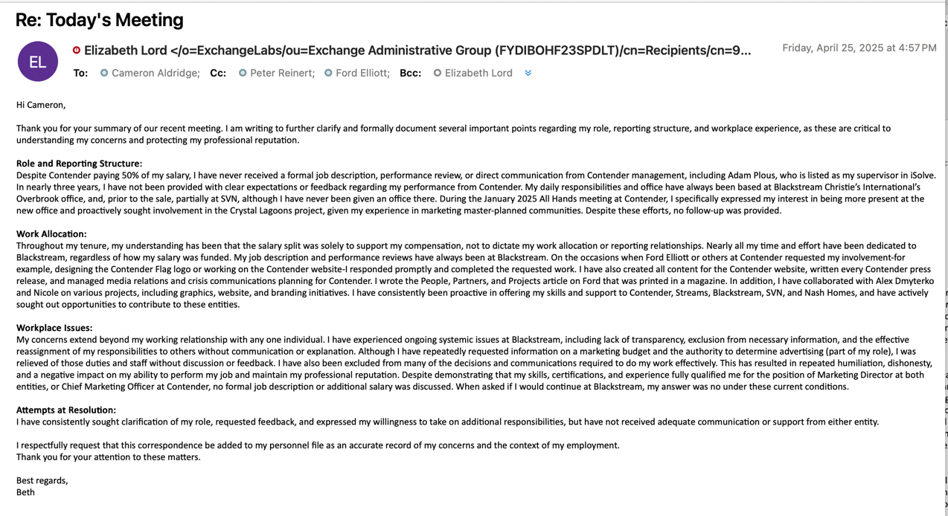
Email from Cameron Aldridge summarizing the meeting and responding to my email. 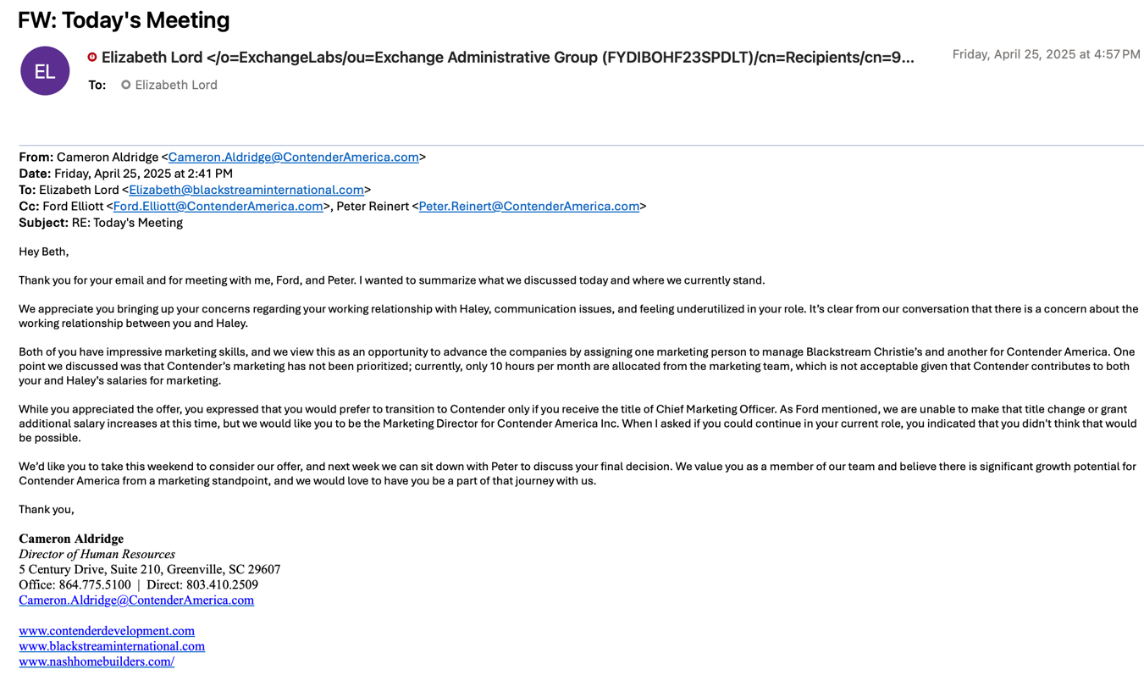

Email from Elizabeth Lord to Cameron Aldridge at close of meeting with HR, Ford Elliott, and Peter Reinhert
